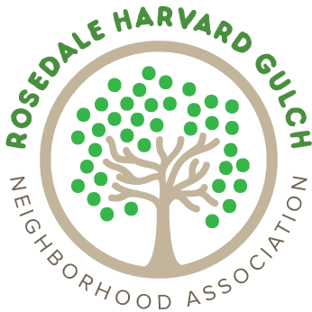
Dear Rosedale Business Owner and Homeowners:
Neighborhood business and Homeowner support is critical to the success of our all-volunteer neighborhood association! Everyone who lives or owns a business or property in our Rosedale neighborhood is a member of RHGNA. We never charge dues.
Please consider sponsoring our organization by placing your logo on our website, https://www.rhgna.org for a year. Your logo will appear at the bottom of every webpage and, if you desire, there will be a click-through option to link your website.
We also connect our neighbors to important happenings in our community and city with E-blasts. Our E-blasts are delivered to 700+ neighbors’ inboxes approximately twice a month.
RHGNA has typically held several events during the year including meetings to inform residents of news that is relevant to the neighborhood and social activities for all ages. We frequently give away door prizes to encourage meeting attendance. If you are interested in donating an item for these events, big or small, please indicate that below. Thanks in advance!
INVOICE – Select all that apply:
Description | Price per year | Additional donation | Total
2023 WWW.RHGNA.ORG Web Ad, (with or without a Click-thru link) | $125
Exclusivity of business (medical, mechanic, realtor, roofing etc) | $300
1 Time Special announcement- Birthday, birth announcement, wedding, graduation etc. | $200
Homeowner | $30

Enclose this invoice with your check, payable to RHGNA, and mail to: RHGNA, P.O. Box 101512, Denver, CO 80250-1512. Or I am happy to visit you at your business or home to take payment via Square.
Questions? Contact Natalie Dorshimer at business@rhgna.org
Please email high-res jpeg of your logo/artwork, this form, and your website (to link) to Natalie Dorshimer at: business@rhgna.org
THANK YOU FOR HELPING US TRANSFORM OUR NEIGHBORHOOD INTO A COMMUNITY

